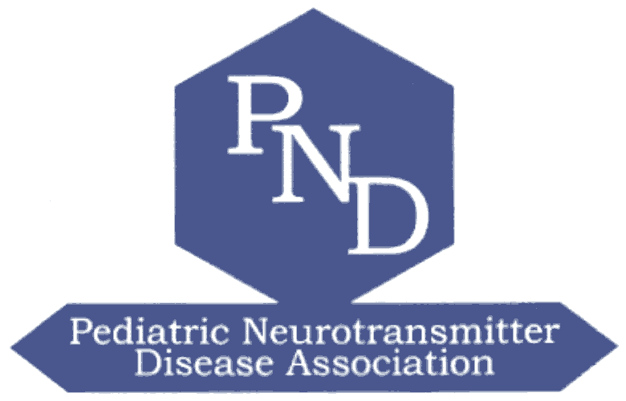

PND ASSOCIATION

FAMILY CONFERENCE
CHILD CARE REQUEST FORM

To solve the dilemma of staying home with the kids and missing out on the meeting, or bringing them along only to be faced with inadequate child care solutions, the PND Association is offering parents a safe and secure, child pleasing experience. To accommodate families who are in need of childcare the PND Association has contracted with ACCENT on Children’s Arrangements, Inc. to provide onsite childcare.

ACCENT is aware of many of our children’s special needs and has experience with this type of childcare. Regretfully provisions are not available for children who are in need of skilled nursing care. Private duty nurses and the child are welcome to attend the program. If you are in need of nursing care for your child please contact the PND Association directly.

ABOUT ACCENT ON CHILDREN’S ARRANGEMENTS

ACCENT on Children’s Arrangements is a national company with staff trained to supervise and entertain your children throughout their stay. ACCENT creates age appropriate, curriculum enriched environments for children with lots of hands on creative activities for children on site. Their professional, specially trained managers are CPR and Pediatric First Aid certified. Accent staff are teachers, professional child care providers or mothers who simply love working with children and have completed Accent’s specialized training program. Accent employee’s references have been thoroughly checked.

Accent on Children’s Arrangements, Inc. has prepared an exciting onsite children’s program called Accent Kids Camp. Children ages 6months-17 years are welcome and will have special age-oriented activities planned for them. Accent Kids camp will be head quartered at the Hyatt Regency Crystal City. Scheduled Activities will take place on site for all children under 7 years old, while older children will have the option to experience the diversity of Washington DC through the educational youth tours that can be planned for each day. On-site children will enjoy arts & crafts projects, active games and much, much more. Youth tours depart from and return to the on-site Accent Kids Camp activity center each day.

STAFFING

ACCENT ‘s staffing ratios and operating procedures meet or exceed standards established by the National Association for the Education of Young Children and the American Academy of Pediatrics Staff ratios for each age group and are;
Infants 6 months –12 months 1:2
Tots 12 months- 36 months 1:3
School Age 3 years- 12 years 1:5
Teen 12 years and older 1:8

SECURITY

ACCENT utilizes “SecurChild” photo security procedure for check-in and out. ACCENT photographs and documents the parent or guardian who drops off the child and ensures that only that person picks up the child. All staff and children are drilled in fire safety and emergency plan.

CHILDREN’S PROGRAM

Camp PND Summer Time Fun – Children under 7 years old

Friday, July 16, 2004
8:00am- 5:30pm

Saturday, July 17, 2004
8:30am-5:00pm

Field Trips - Children 7 years old and older

Friday July 16, 2004
10:00am-5:00pm
National Air and Space Museum

Saturday July 17, 2004
10:00am-4:00pm

Smithsonian National Zoological Park

Fees

Children 36 months and younger $12.00 per hour (3 hour minimum)
Children 3 years and older $10.00 per hour (3 hour minimum)
National Air and Space Museum $88.00 per child
Smithsonian National Zoological Park $79.00 per child

If you are interested in utilizing these services please complete the following and mail, email or fax to the PND Association: 6 Nathan Drive , Plainview NY 11803, Phone/Fax 516 937-0049
PND@PNDAssoc.org

Name: ________________________________

Yes I am interested in childcare provisions:_____________

Number and age of children: ___________________________________________

Services needed:______________________________________________

Special Needs of children:______________________________

